## The Scale Marker

This tool is handy for advising viewers of the plan that there is a scale set. You are able to set the plan distance in **Imperial** and **Metric** system.

## To place a Scale Marker

* Select the Scale Marker from the Annotations tab in the Tools Palette.
* Click once anywhere on your plan to place the marker.
* Edit the values for the marker within the Properties Palette.
* 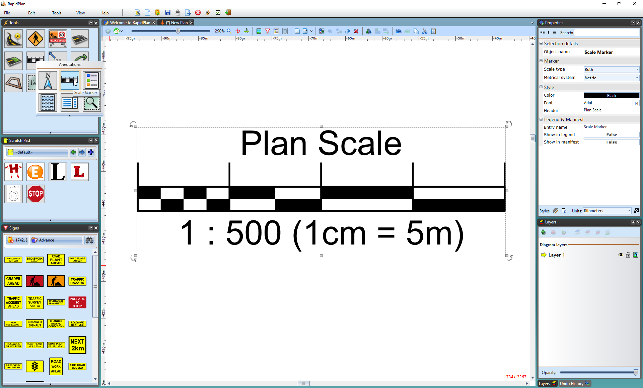
* Scale_Marker_and_Properties_Palette